Recruitment – Supporting Information

Role Name: Crisis Worker
Locations: Gwent, South Wales, Mid and West Wales
Salary: Competitive shift and hourly rates
Hours: On call basis – Day time and out of hours shifts including weekends
Term: Zero hours contract
Website: http://www.newpathways.org.uk/jobs/

Summary
Can you help us work toward a world without rape or sexual violence? We are looking for Crisis Workers to join our teams across Gwent, South Wales, Mid and West Wales.

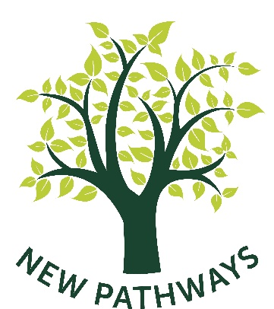
About Us
New Pathways are committed to providing specialist services for everyone who has experienced recent or historical sexual violence (sexual abuse or rape). New Pathways started life nearly 30 years ago as a voluntary sexual violence counselling service. We have developed to provide a complete advocacy and support solution for adults and children including: Sexual Abuse Referral Centres (SARCs), crisis workers, independent sexual violence advisors, sexual violence support workers and sexual violence counsellors. We are recognised as a leading provider of sexual violence specialist training as well as a large volunteer program. We work throughout South, Mid and West Wales.

- About the role: The successful applicants will join our teams in Gwent, South Wales, Mid and West Wales to provide crisis intervention & support to victims of rape and sexual assault at our Sexual Assault Referral Centres (SARC). Crisis workers responsibilities include opening and preparing the SARC for the arrival of a victim. They offer support to victims of sexual violence during forensic medical examinations and police interviews. In addition, they liaise with the Police and Medical Examiners regarding the SARC process.

- About you: You will share our aims (http://www.newpathways.org.uk/our-aims/) and embody New Pathways’ ethos and values. We are looking for people who are motivated, enthusiastic, passionate about our work, and who want to make a positive difference to the lives of others. You must have good interpersonal and communication skills and be able to hold strict confidentiality. A warm & empathic disposition is essential, and you must have the ability to hold & maintain boundaries.

You will be someone who likes to engage with and support others to get the best out of their experiences, have great organisational skills and good emotional intelligence. Continual improvement will be an innate part of your approach and you will thrive as an important part of our committed team. We know this role is a challenging one but is also one which brings considerable rewards.
We believe that our clients deserve the best possible service, and we work hard to achieve this. If you think that you have the skills and qualities that we are looking for, then we would love to hear from you.
Benefits of working with New Pathways in this role
- High level of professional and wellbeing support
- Flexible working patterns.
- A package of wellbeing support including self-care workshops, reflective practice meetings,
- Access to training, relevant to the role.
- Continuous opportunities for career development
- Access to supervision for all staff
- Access to Health Assured 24 hour telephone crisis support
- Access to Health Assured counselling
- Mentor and ‘buddy’ system for all new staff
- Staff ‘Away Days’
- Organisational sick pay
Full Job Descriptions and application forms can be found on our website Job Vacancies » New Pathways
Additional Information
New Pathways are equal opportunities employers, we value diversity and are strongly committed to providing equal employment opportunities for all employees and all applications for employment.

